**2022 Term 4**

**Year 8 Science**

**Chemistry Topic Test**

|  |  |
| --- | --- |
| Multiple Choice | / 10 |
| Short Answer | / 42 |
| TOTAL | / 52 |
| Percentage | % |

**Name:**  __________

**Teacher:**

## MULTIPLE CHOICE ANSWER SHEET

Mark your answer with an ‘X’

|  |  |  |  |  |
| --- | --- | --- | --- | --- |
| **1** | A | B | C | D |
| **2** | A | B | C | D |
| **3** | A | B | C | D |
| **4** | A | B | C | D |
| **5** | A | B | C | D |
| **6** | A | B | C | D |
| **7** | A | B | C | D |
| **8** | A | B | C | D |
| **9** | A | B | C | D |
| **10** | A | B | C | D |

**SECTION ONE: MULTIPLE CHOICE**

Answer the following questions on the separate multiple-choice sheet.

1. Matter that is only composed of one type of atom is called a(n) ……………….
2. Element
3. Compound
4. Mixture
5. The Periodic Table is organised in which of the following ways?

1. Vertical Periods, horizontal groups, and elements in alphabetical order.
2. Vertical Periods, horizontal groups, and elements in increasing atomic number.
3. Horizontal Periods, vertical groups, and elements in alphabetical order.
4. Horizontal Periods, vertical groups, and elements in increasing atomic number.
5. Which one of the following gases is a compound?
6. H2
7. CO2
8. O2
9. N2
10. The atomic number of an element tell us:
11. The weight of its atoms
12. When it was discovered
13. The number of neutrons in one atom
14. The number of protons in one atom
15. 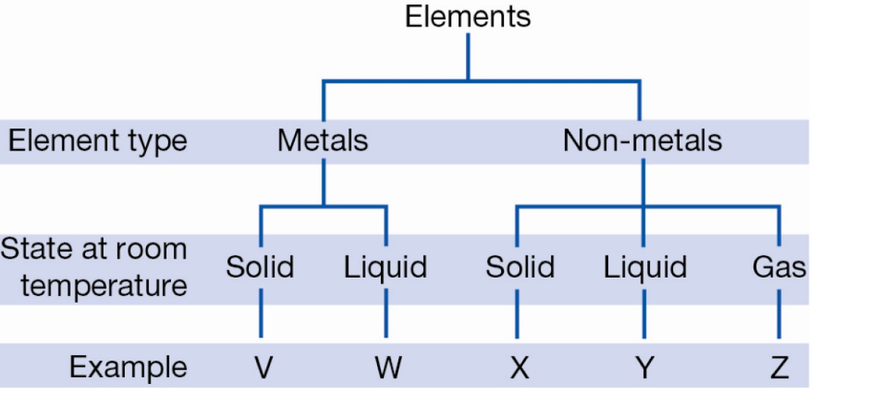

Using the above diagram, it can be ***inferred*** that Mercury and Oxygen are:

1. W and Z respectively
2. V and Z respectively
3. Z and W respectively
4. Z and V respectively
5. The molecular formula for acetaldehyde is C2H4O. It contains the following atoms:
   1. 1x carbon, 2x hydrogen, 4x oxygen
   2. 1x carbon, 2x helium, 4x oxygen
   3. 2x carbon, 4x hydrogen, 1x oxygen
   4. 2x carbon, 4x helium, 1x oxygen
6. As a solid object is heated, its particles:
   1. Vibrate less rapidly and cause the object to contract
   2. Vibrate more rapidly and cause the object to expand
   3. Attract each other more, causing contraction
   4. Expand individually, causing the object to decrease in volume
7. The electrical conductivity for four metals at different temperatures is shown in the graph below.

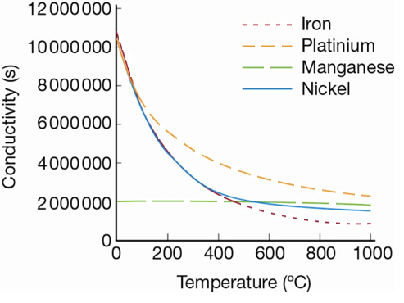

According to this graph, the best conductor at 900°C is:

* 1. Iron
  2. Manganese
  3. Platinum
  4. Nickel

1. Below -78.5°C carbon dioxide is a solid. Above this temperature it is a gas. Which process does carbon dioxide undergo as it changes from a solid to a gas?
   1. Evaporation
   2. Sublimation
   3. Melting
   4. Condensation
2. A student carries out an experiment to determine the effect of different types of salt solutions on an iron nail. Identify the purpose of the test tube containing the nail and water only.

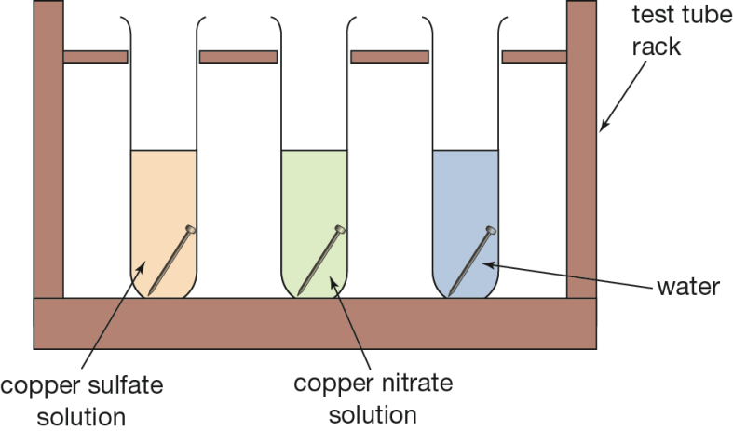

* 1. It allows a comparison between copper nitrate and copper sulfate
  2. The water is added to test the strength of the nail
  3. It is a control for the experiment
  4. All of the answers are correct

**SECTION TWO: SHORT ANSWER**

1. Complete the table below by describing the changes as either physical or chemical. (2 marks)

|  |  |
| --- | --- |
| **Example** | **Type of Change**  (Physical/Chemical) |
| Burning a piece of wood |  |
| Ice melting |  |
| Bread rising in the oven |  |
| Car metal rusting |  |

1. State two (2) key detectable signs of both physical and chemical change. (4 marks)

|  |  |  |
| --- | --- | --- |
|  | **PHYSICAL CHANGE** | **CHEMICAL CHANGE** |
| **Key Feature #1** |  |  |
| **Key Feature #2** |  |  |

1. Density is a measure of the total amount of mass in a certain volume. Below are four 1 cm cubes of different metals.

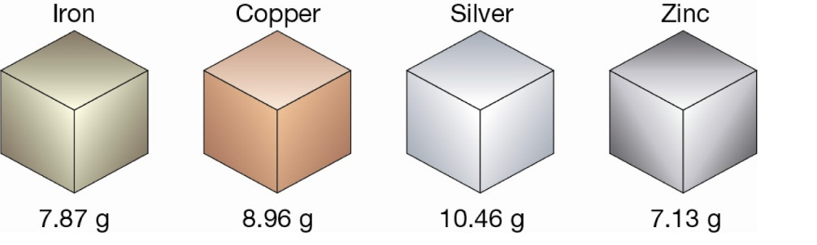

1. Identify which metal has the highest density (1 mark)

________________________

1. Iron can be found in the mineral hematite. The chemical formula for hematite is Fe2O3. Name the other element found in hematite. (1 mark)

______________________

1. Identify hematite as either an **element, compound,** or **mixture.** (1 mark)

________________________

1. Use your understanding of the periodic table to explain why **CO** and **Co** are not the same substance. (2 marks)

|  |
| --- |
|  |
|  |
|  |
|  |

1. Complete the table below with the names of the 3 sub atomic particles and their charges: (2 marks)

|  |  |  |  |
| --- | --- | --- | --- |
|  | **Sub Atomic Particle:** | | |
| **NAME** | PROTON |  |  |
| **CHARGE** |  |  | NEGATIVE |

1. Complete the tables below with the missing element name or symbol:

(6 marks)

|  |  |
| --- | --- |
| **ELEMENT NAME** | **ELEMENT SYMBOL** |
| Potassium |  |
| Sulfur |  |
| Carbon |  |
| Manganese |  |
| Neon |  |
| Sodium |  |

|  |  |
| --- | --- |
| **ELEMENT SYMBOL** | **ELEMENT NAME** |
| Ar |  |
| B |  |
| Cl |  |
| N |  |
| Cu |  |
| He |  |

1. For the below element label or name what each of the arrows tell us about the element: (2 marks)

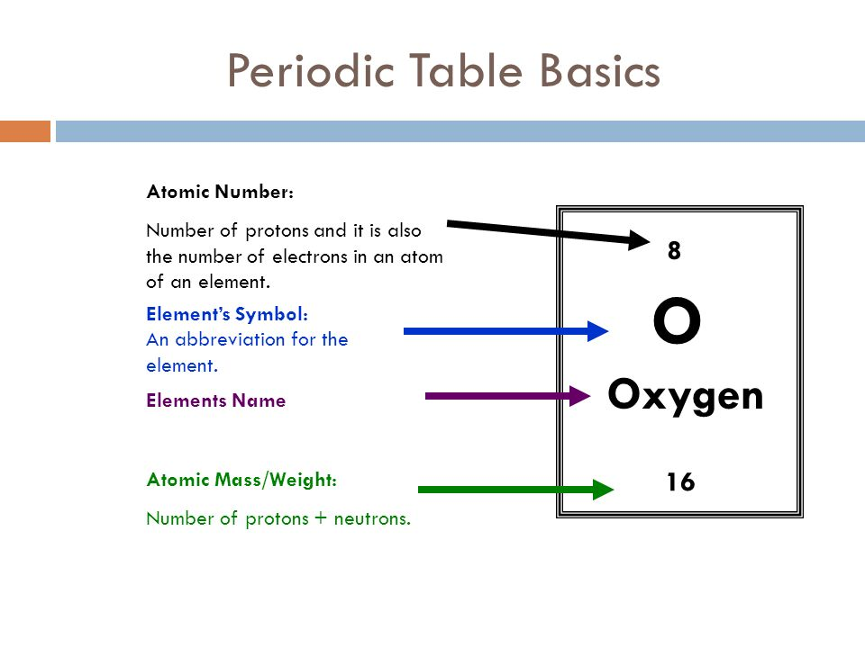

1. Identify which of the following compounds is most likely to have molecules like that of the diagram below: (1 mark)
2. Sodium Chloride, NaCl
3. Ammonia, NH3
4. Methane, CH4
5. Water, H2O
6. Emma has written down some statements. She wants to know which statements are about solids, which are about liquids and which are about gases. (3 marks)

A It changes its shape if its container is tipped.

B It is difficult to push into a smaller space.

C It expands when heated.

D Its particles are moving.

E It spreads out to fill a room.

F Its particles have the strongest forces of attraction.

G There are large spaces between its particles.

(Note: Statements can be used more than once, once or not at all.)

1. Write the letters of the statements which describe a solid. _________________

1. Write the letters of those which describe a liquid.

_________________

1. Write the letters of those which describe a gas.

_________________

1. Using the following symbols draw in the boxes below, an example of each description:   
    (4 marks)
   * 1. An Element ii. A Compound iii. Mixture of elements iv. Mixture of   
         compounds
   1. Write the states (liquid, solid, gas) in the below boxes in order of increasing energy: (1 mark)

Lowest energy

Highest energy

* 1. Name the process that is illustrated by the arrow in the below diagram. Write your answer in the box below the large arrow. (1 mark)

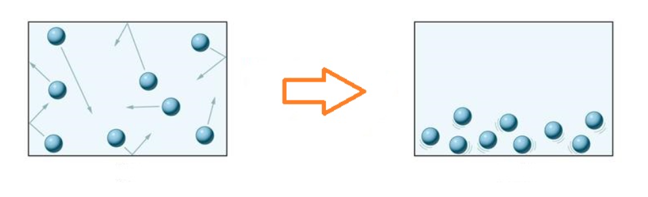

* 1. Complete the table below by defining the following physical properties

(4 marks)

|  |  |
| --- | --- |
| **Physical Property** | **Definition** |
| Malleable |  |
| Melting Point |  |
| Conductivity |  |
| Mass |  |

1. A chemist made a very exciting discovery of a brand-new element not yet named. She created a diagram that represented how it would look on the periodic table.

120

bH

197

* 1. How many electrons does this element have? _______ (1 mark)
  2. How many neutrons does this element have? _______ (1 mark)
  3. What is wrong with the chemical symbol she has chosen? (1 mark)

______________________________________________________________

After completing a number of tests on the new element, the chemist found that it shattered into smaller pieces when pressure was applied, and was a poor conductor of electricity. She decided that it should be placed on the left side of the periodic table.

* 1. Was the chemist’s decision about the elements position on the periodic table correct? (1 mark)

____________________

* 1. Justify your answer to part (d) above. (3 marks)

____________________________________________________________________________________________________________________________

____________________________________________________________________________________________________________________________

**END OF TEST**

**Finished? Try this WordSearch 😊**

